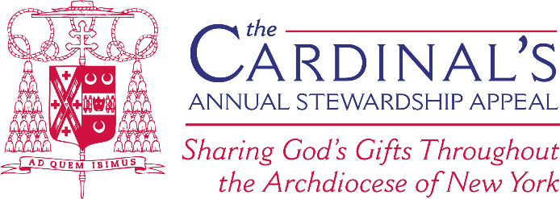

Pre-Commitment Weekend Script- 2025 Appeal

Next weekend, on XX Date, we will conduct our Commitment Weekend for the 2024 Cardinal’s Appeal, which is when we will collect the pledge envelopes with your gift. To date, XX parish households have responded allowing us to reach $ or (%) of our Appeal goal of $XX.
Thank you for the early support of those parishioners who have already made a gift.
I am asking everyone to please complete the response envelope that you receive in the mail (also available in the back of the church) or to make your gift at www.cardinalsappeal.org/donate. Please bring it to Mass next weekend or put it in the mail with a stamp, which will go directly to the archdiocese. Be sure to direct your gift to PARISH NAME, CITY NAME so that our parish receives credit for your donation.
Next weekend is the big push to reach our goal; this will only be possible if every household makes their commitment. A response from every member of our parish family would be a tremendous blessing.
I deeply appreciate your pledge to share your time, talent, and treasure with our broader Church community.

