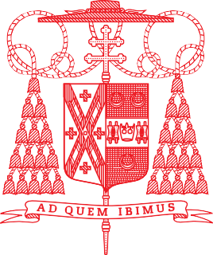

Office of the Cardinal
488 Madison Avenue, 3rd Floor
New York, NY 10022

January 2, 2026
Month of the Holy Name of Jesus
Christmas Season

Dear Friend,

A blessed New Year! Thanks be to God, and to you, the Cardinal’s Annual Stewardship Appeal went over goal again last year, raising more than $21 million for the work of the Church.

May I invite you to be just as generous to the 2026 Appeal? Every dollar you give is put to work right away, supporting our ministries, helping our poor parishes and struggling Catholic schools, caring for our retired clergy, forming the next generation of priests, and sustaining our outreach to the poor. Your gift also funds the Sharing God’s Gifts Pastoral Grants Program, which is establishing new ministry initiatives or strengthening existing ones.

People often tell me, “Cardinal Dolan, I love what the Church is doing!” I reply, “So do I — and it’s thanks to you.” Then they add, “I wish the Church could do even more,” and I say, “Together, we can. It’s your ongoing generosity that makes that possible.”

Will you consider a gift to the 2026 Appeal? Your generosity keeps our promise alive that no matter the challenge, the Church will always be there, offering hope wherever God’s people are in need.

Please persevere! I am proud to be your archbishop, grateful for your love for Jesus and His Church, and I promise you my prayers and blessings for a joyful, faith-filled 2026.

With deepest gratitude and prayerful wishes, I am,

Faithfully in Christ,

†Timothy Michael Cardinal Dolan
Archbishop of New York

P.S. To make your contribution, please scan the QR code, visit us at www.cardinalsappeal.org/donate, or call our office at (646) 794-3300.

