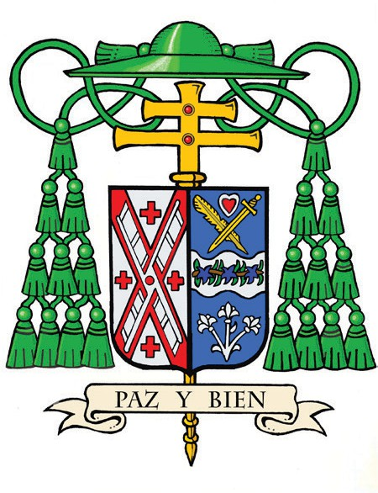
Office of the Archbishop
488 Madison Avenue,
3rd Floor
New York, NY 10022

February 11, 2026

Dear Friend,

Grace and peace to you in Christ Jesus.

Since my appointment as the Archbishop of New York, I have been deeply humbled by the welcome extended to me by the people of this great archdiocese. Having served most recently as Bishop of Joliet, Illinois, and previously as an auxiliary bishop and parish priest in Chicago, I come to this ministry with a profound sense of mission and a heart full of gratitude for the opportunity to walk with you as we proclaim the Gospel in service to all God’s people.

As I am preparing to serve as your shepherd, I am writing today to invite you to join me in support of the 2026 Cardinal’s Annual Stewardship Appeal. This vital appeal is central to our ability to sustain the life-giving ministries of the Church throughout the archdiocese.

Through your generosity, we support Catholic schools and struggling parishes, prepare seminarians for priestly ministry, and provide life-sustaining assistance through Catholic Charities and other charitable works. Especially in times of uncertainty, the Church’s presence of hope and service depends upon the faithful generosity of those who believe in this mission.

I ask you to prayerfully consider a gift to this year’s Appeal as a sign of your partnership in the life of the Church. It is through your faithful stewardship that we extend Christ’s compassion and service to every corner of our community.

Thank you again for your warm welcome, for your trust, your prayers, and your steadfast support of the Church in New York. Please know that I hold you and your loved ones in my prayers.

With best wishes, I remain

Sincerely yours in Christ,
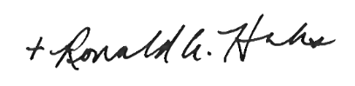

The Most Reverend Ronald A. Hicks
Archbishop of New York

P.S. To make your contribution, please scan the QR code, visit us at www.cardinalsappeal.org/donate, or call our office at (646) 794-3300.

