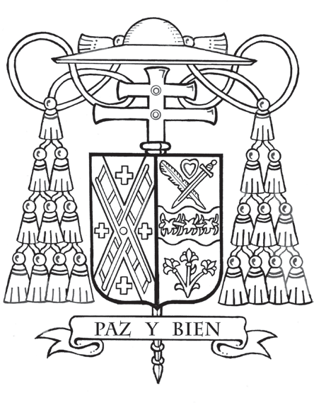
Office of the Archbishop
488 Madison Avenue, 3rd Floor
New York, NY 10022

May 4, 2026
Month of Our Lady
Paschaltide

Dear Friend,

In the life of the Church, there are moments that remind us that God continues to work among us. Whether you have learned about the Cardinal’s Annual Stewardship Appeal through your pastor, have supported it in the past, or are prayerfully considering your participation, I am grateful that you keep the Church in your prayers and discernment.

On May 23, 2026, I will ordain Joseph Haas and John Ippolito as priests for our archdiocese. Their “yes” grew over time through prayer, questions, and a willingness to listen for the Lord’s voice. I am deeply grateful for their openness and their desire to serve God’s people. Their witness brings to mind my own call, which unfolded in a similar way, not all at once, but step by step, learning to trust where the Lord was leading. This is often how God works, quietly and patiently, drawing us forward.

Recently, during a Vocations Day at St. Joseph’s Seminary, I spent time with over 200 young men who are discerning what God may be asking of them. There was a quiet seriousness among them, along with a sense of hope. It was a reminder that the future of the Church is already taking shape and that God continues to call disciples, not only those who are preparing for the priesthood, but also each one of us.


The Appeal is one way we respond to God’s call together, strengthening our parishes, supporting our schools, serving those in need, and forming seminarians for the priesthood. The needs of our archdiocese remain real, and many parishes are experiencing the effects of delayed participation. Your support at this time helps ensure that this essential work continues.

Each of us is personally called to share in the life and mission of the Church. I invite you to take part in this mission today with a gift by visiting cardinalsappeal.org/May2026 or scanning the QR code.

I know that for many of you, this is a time of getting to know me as your new archbishop. In the coming months, I look forward to continuing to visit parishes across the archdiocese and to meeting you. Together, we can ensure that the Church in New York remains open for those seeking Christ in the Eucharist, His mercy in Reconciliation, and a deeper relationship with Him and His mission today.

Please keep Joseph and John in your prayers. Be assured of mine for you and your loved ones. As I remain,

Sincerely yours in Christ,
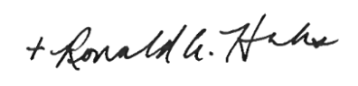

The Most Reverend Ronald A. Hicks
Archbishop of New York

