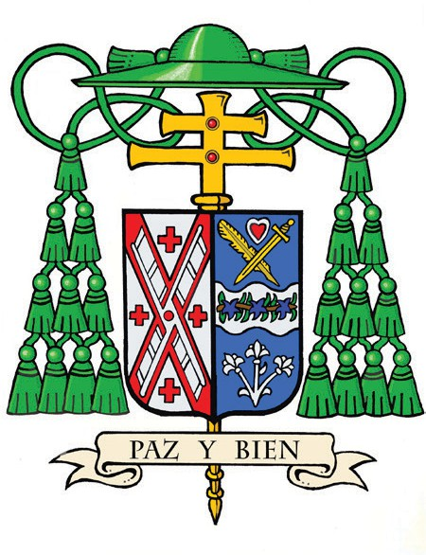
Office of the Archbishop
488 Madison Avenue,
3rd Floor
New York, NY 10022

October 30, 2026
Month of the Holy Rosary

Dear Friend,

Paz y bien. Peace and all good things.

These words have accompanied me for many years. They express a simple prayer I carry each day: that we may know the peace of Jesus Christ and share His goodness with one another.

This past summer brought an unexpected period of quiet during my recovery from retinal surgery. That time allowed me to pray more deeply and reminded me how completely we depend upon the grace of God and upon one another. The same is true of the Church.

Jesus calls us not only to believe in Him, but to follow Him and put our faith into action. Through the Cardinal’s Annual Stewardship Appeal, we do this together by educating our children, caring for the poor and vulnerable, forming men for the priesthood, supporting our retired priests, and sustaining ministries that bring the presence of Christ to people throughout the archdiocese.

As the 2026 Appeal draws to a close, I ask you to prayerfully consider a gift to the Appeal by visiting cardinalsappeal.org/November2026. If you have already made a gift this year, please accept my sincere thanks. If you have not yet participated, I hope you will join us now, when a generous donor will match gifts made by Giving Tuesday, December 1, up to $100,000.

As we look ahead, we must remain close to Jesus, strengthened by the Eucharist, attentive to those who might otherwise be forgotten, and willing to go where we are needed. Beginning in 2027, the Cardinal’s Annual Stewardship Appeal will become the Archbishop’s Appeal for Catholic Ministries. While the name will change, its purpose will remain the same: supporting the ministries through which the Church serves God’s people throughout the archdiocese.

Please continue to pray for me, as so many of you kindly did during my recovery. Pray that I may follow the heart of Jesus faithfully and serve you well as your shepherd.

Know that I continue to pray for you, your families, and all the people of this archdiocese.

With best wishes, I remain,
Sincerely yours in Christ,



The Most Reverend Ronald A. Hicks
Archbishop of New York

